Fundamentals of Data Science
Assessment Tool 3
Question 5 – Agriculture Crop Yield Dataset
Objective
The objective of this analysis is to perform Exploratory Data Analysis (EDA) on an agriculture crop yield dataset to examine the relationship between rainfall, temperature, fertilizer usage, soil type, and crop yield. The analysis aims to identify the key factors that influence agricultural productivity, discover patterns in crop production under different environmental conditions, and provide insights for improving farming practices. The findings can support farmers, agricultural researchers, and policymakers in making informed decisions to increase crop yield, optimize resource utilization, and promote sustainable agriculture.

# ==========================================================
# Import Required Libraries
# ==========================================================
import pandas as pd import numpy as np import matplotlib.pyplot as plt import seaborn as sns %matplotlib inline
plt.style.use("ggplot") sns.set_theme(style="whitegrid") print("Libraries imported successfully.")
In [1]:
Libraries imported successfully.
Dataset Description
Problem Statement
An agricultural department wants to analyze crop yield based on rainfall, temperature, fertilizer usage, and soil type. The objective is to understand how these factors affect agricultural productivity, identify conditions that lead to higher crop yields, and support data-driven decisions for improving farming practices and resource management.
Farm_ID
Rainfall_mm
Temperature
Fertilizer_kg
Soil_Type
Crop_Yield_kg
Target-Variable
Crop_Yield_kg
# ==========================================================
# Create Agriculture Dataset
# ========================================================== crop = {
"Farm_ID":["F01","F02","F03","F04","F05","F06","F07","F08","F09","F10",
"F11","F12","F13","F14","F15","F16","F17","F18","F19","F20"],
"Rainfall_mm":[850,600,900,500,780,650,920,720,550,800,
880,620,760,940,580,820,700,960,540,790],
In [2]:
"Temperature":[28,32,27,34,29,31,26,30,33,28, 27,32,29,26,33,28,30,25,34,29],
"Fertilizer_kg":[60,45,65,40,55,48,70,52,42,58, 62,46,54,72,44,60,50,75,41,56],
"Soil_Type":["Loamy","Sandy","Loamy","Sandy","Clay",
"Sandy","Loamy","Clay","Sandy","Loamy",
"Loamy","Sandy","Clay","Loamy","Sandy", "Clay","Clay","Loamy","Sandy","Clay"],
"Crop_Yield_kg":[3200,2100,3500,1800,3000,2300,
3700,2800,1900,3100,
3400,2200,2950,3800,2000,
3150,2700,3900,1850,3050]
} df5 = pd.DataFrame(crop) df5.head()
Out[2]
F01 | 850 | 28 | 60 | Loamy | 3200
F02 | 600 | 32 | 45 | Sandy | 2100
F03 | 900 | 27 | 65 | Loamy | 3500
F04 | 500 | 34 | 40 | Sandy | 1800
F05 | 780 | 29 | 55 | Clay | 3000
# ==========================================================
# Dataset Understanding
# ==========================================================
print("Shape of Dataset:") print(df5.shape)
print("\nDataset Information:") df5.info()
print("\nData Types:") print(df5.dtypes)
In [3]:
Shape of Dataset:
(20, 6)
Dataset Information:
<class 'pandas.DataFrame'>
RangeIndex: 20 entries, 0 to 19 Data columns (total 6 columns):
# Column Non-Null Count Dtype --- ------ -------------- ---- 0 Farm_ID 20 non-null str
- Rainfall_mm 20 non-null int64
- Temperature 20 non-null int64
- Fertilizer_kg 20 non-null int64
- Soil_Type 20 non-null str 5 Crop_Yield_kg 20 non-null int64 dtypes: int64(4), str(2) memory usage: 1.1 KB
Data Types:
Farm_ID str
Rainfall_mm int64
Temperature int64
Fertilizer_kg int64
Soil_Type str Crop_Yield_kg int64 dtype: object
# ==========================================================
# Data Cleaning
# ==========================================================
print("Missing Values") print(df5.isnull().sum())
print("\nDuplicate Records") print(df5.duplicated().sum())
print("\nAvailable Soil Types") print(df5["Soil_Type"].unique())
In [4]:
Missing Values
Farm_ID 0
Rainfall_mm 0
Temperature 0
Fertilizer_kg 0
Soil_Type 0 Crop_Yield_kg 0 dtype: int64
Duplicate Records
0
Available Soil Types
<StringArray>
['Loamy', 'Sandy', 'Clay']
Length: 3, dtype: str
In [5]: # ==========================================================
# Descriptive Statistics
# ========================================================== df5.describe()
Out[5]:
20.000000 | 20.000000 | 20.000000 | 20.000000
743.000000 | 29.550000 | 54.750000 | 2820.000000
144.335136 | 2.762055 | 10.507516 | 681.407213
500.000000 | 25.000000 | 40.000000 | 1800.000000
615.000000 | 27.750000 | 45.750000 | 2175.000000
770.000000 | 29.000000 | 54.500000 | 2975.000000
857.500000 | 32.000000 | 60.500000 | 3250.000000
960.000000 | 34.000000 | 75.000000 | 3900.000000
In [6]: # ==========================================================
# Numerical and Categorical Analysis
# ========================================================== print("Average Rainfall:", df5["Rainfall_mm"].mean()) print("Average Temperature:", df5["Temperature"].mean()) print("Average Fertilizer:", df5["Fertilizer_kg"].mean()) print("Average Crop Yield:", df5["Crop_Yield_kg"].mean()) print("\nSoil Type Count") print(df5["Soil_Type"].value_counts())
Average Rainfall: 743.0
Average Temperature: 29.55
Average Fertilizer: 54.75
Average Crop Yield: 2820.0
Soil Type Count
Soil_Type
Loamy 7
Sandy 7
Clay 6
# ==========================================================
# Bar Chart
# ========================================================== plt.figure(figsize=(6,4)) df5["Soil_Type"].value_counts().plot(kind="bar") plt.title("Soil Type Distribution") plt.xlabel("Soil Type") plt.ylabel("Number of Farms") plt.show()
Name: count, dtype: int64 In [7]:
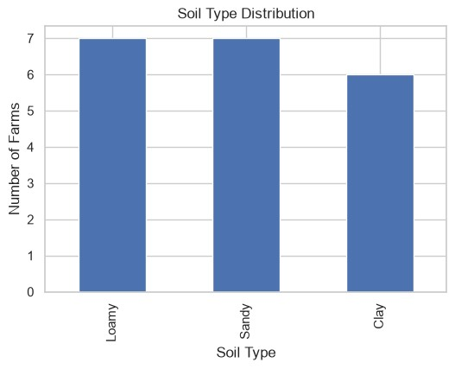
# ==========================================================
# Histogram
In [8]:
# ========================================================== plt.figure(figsize=(6,4)) plt.hist(df5["Crop_Yield_kg"], bins=6, edgecolor="black") plt.title("Crop Yield Distribution") plt.xlabel("Crop Yield (kg)") plt.ylabel("Frequency") plt.show()
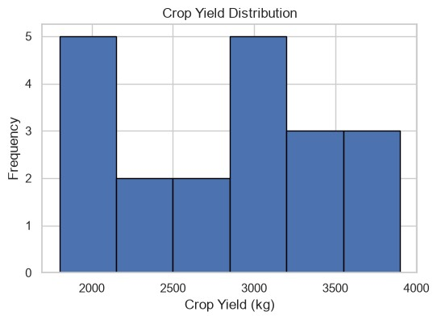
# ==========================================================
# Scatter Plot
# ========================================================== plt.figure(figsize=(6,4)) plt.scatter(df5["Rainfall_mm"], df5["Crop_Yield_kg"]) plt.title("Rainfall vs Crop Yield") plt.xlabel("Rainfall (mm)") plt.ylabel("Crop Yield (kg)") plt.show()
In [9]:
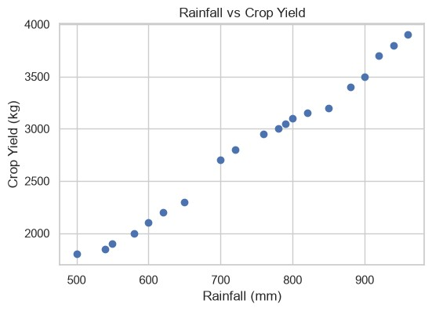
# ==========================================================
# Box Plot
# ========================================================== plt.figure(figsize=(6,4)) plt.boxplot(df5["Crop_Yield_kg"]) plt.title("Crop Yield Box Plot") plt.ylabel("Crop Yield (kg)") plt.show()
In [10]:
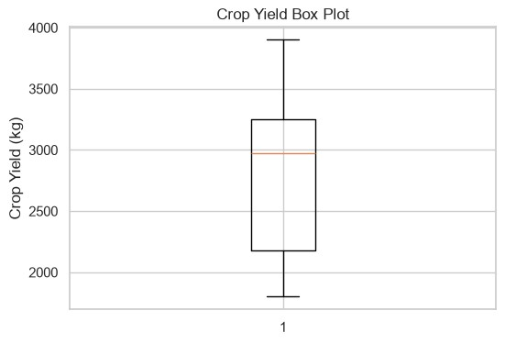
# ==========================================================
# Pie Chart
# ========================================================== plt.figure(figsize=(5,5))
df5["Soil_Type"].value_counts().plot( kind="pie", autopct="%1.1f%%"
) plt.title("Soil Type Percentage") plt.ylabel("") plt.show()
In [11]:
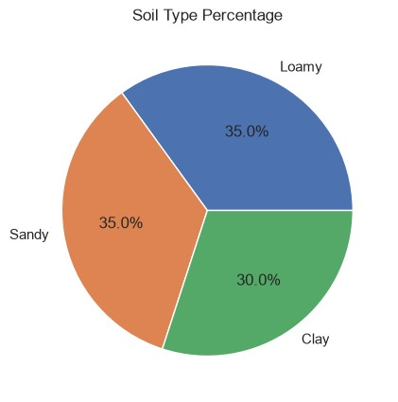
# ==========================================================
# Heatmap
# ========================================================== plt.figure(figsize=(6,4))
sns.heatmap( df5.select_dtypes(include=np.number).corr(), annot=True, cmap="coolwarm"
) plt.title("Correlation Heatmap") plt.show()
In [12]:
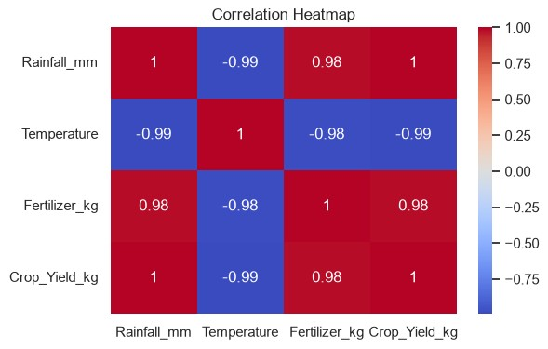
- Farms receiving higher rainfall generally produced higher crop yields.
- Loamy soil recorded better crop production than sandy soil.
- Higher fertilizer usage was associated with increased crop yield.
- No missing values or duplicate records were found.
- Rainfall and fertilizer usage showed a positive relationship with crop yield.
The Exploratory Data Analysis (EDA) indicates that rainfall, temperature, fertilizer usage, and soil type play a significant role in influencing crop yield. The dataset was successfully cleaned and preprocessed, making it suitable for accurate analysis. The findings highlight how environmental conditions and farming practices affect agricultural productivity. These insights can help farmers and agricultural departments make informed decisions on crop planning, fertilizer management, irrigation, and resource allocation, ultimately improving crop yield, increasing productivity, and promoting sustainable farming practices

